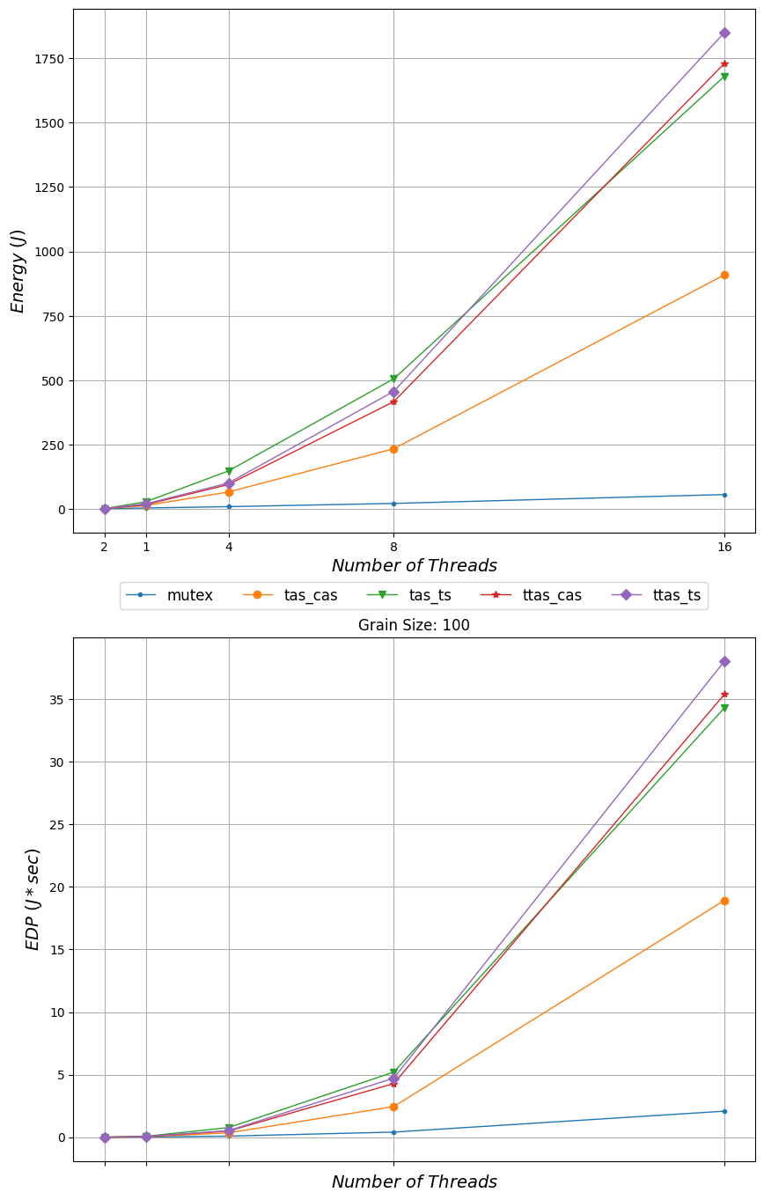

1750

1500

1250+

1000

*Energy ()*

15

500+

250+

2

1

mutex

*Number of Threads - tas_cas tas_ts +*

Grain Size: 100

ttas_cas

t tas_ts

*EDP (/* sec)*

*Number of Threads*